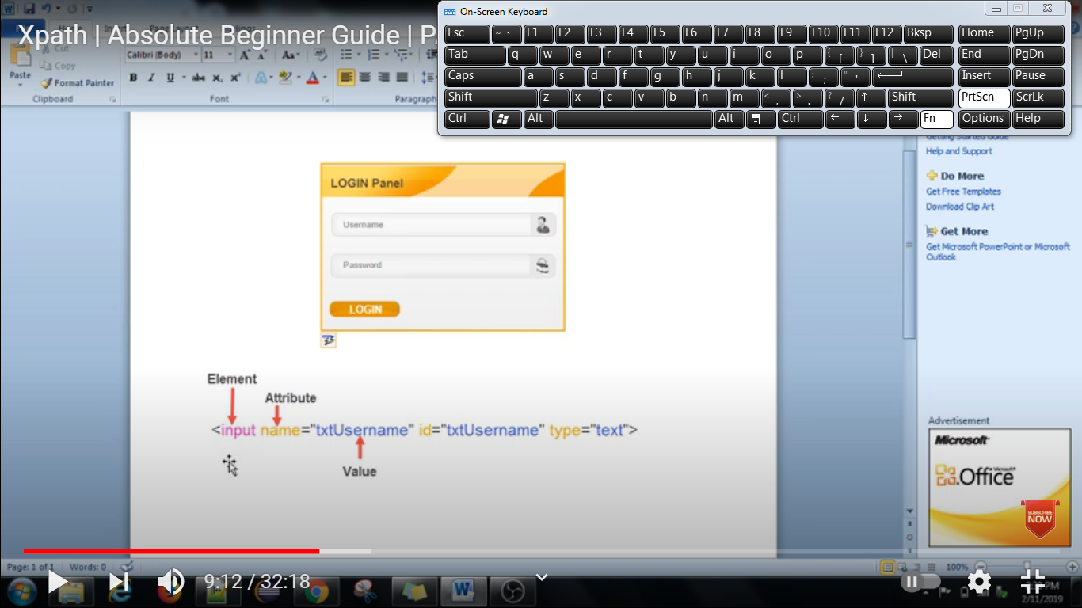

a) Locating Elements with Known Attribute

b) Locating Elements with known Element and Attributes

c) Locating Elements with Known Visible Text (exact match)

d) Locating Elements when part of the visible text (partial match)

e) Locating Elements with Multiple Attributes

f) Locating elements when starting visible text is known

g) Locating Elements with Dynamic Attribute values

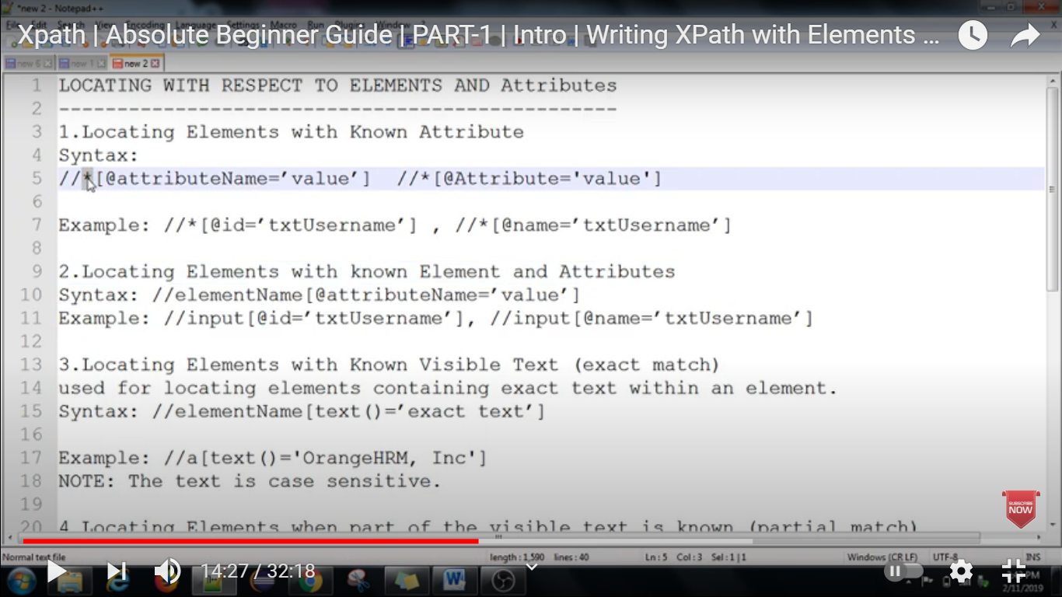

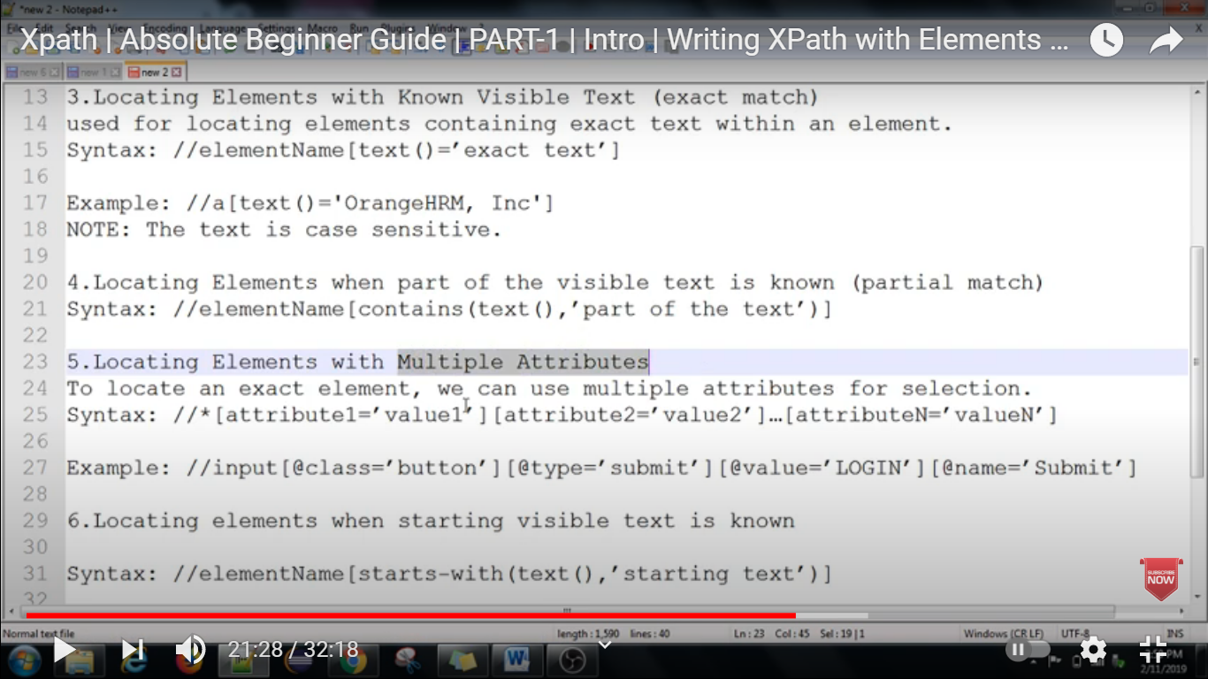

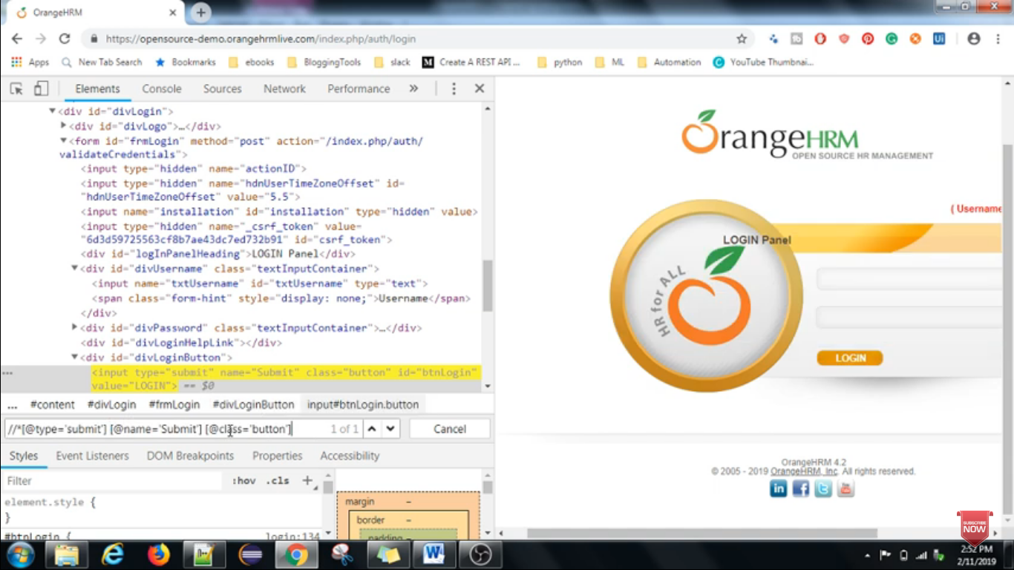

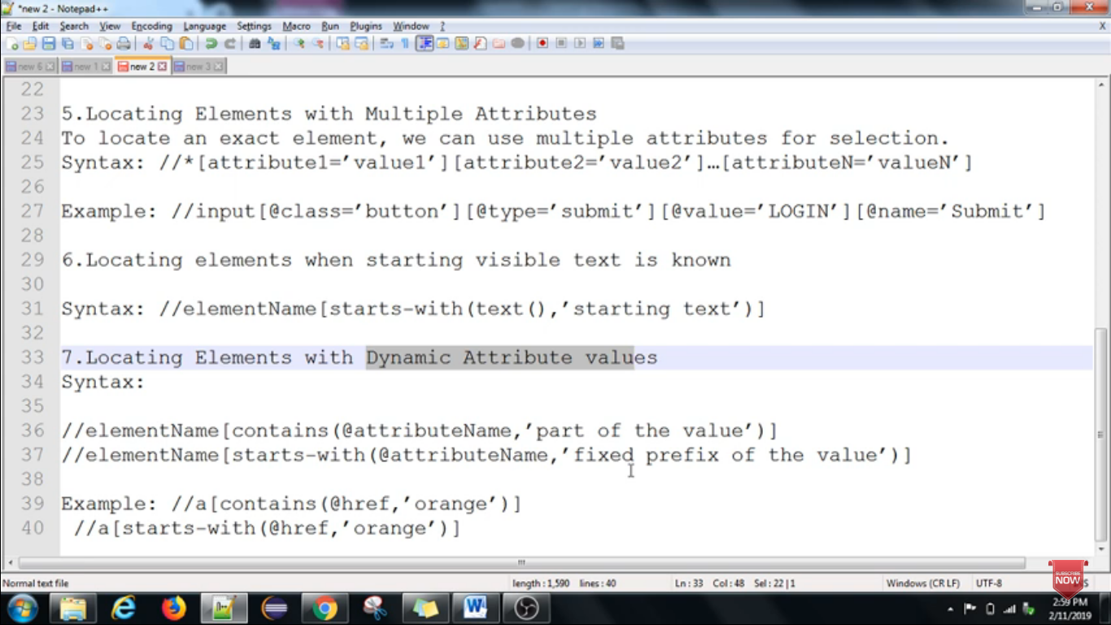

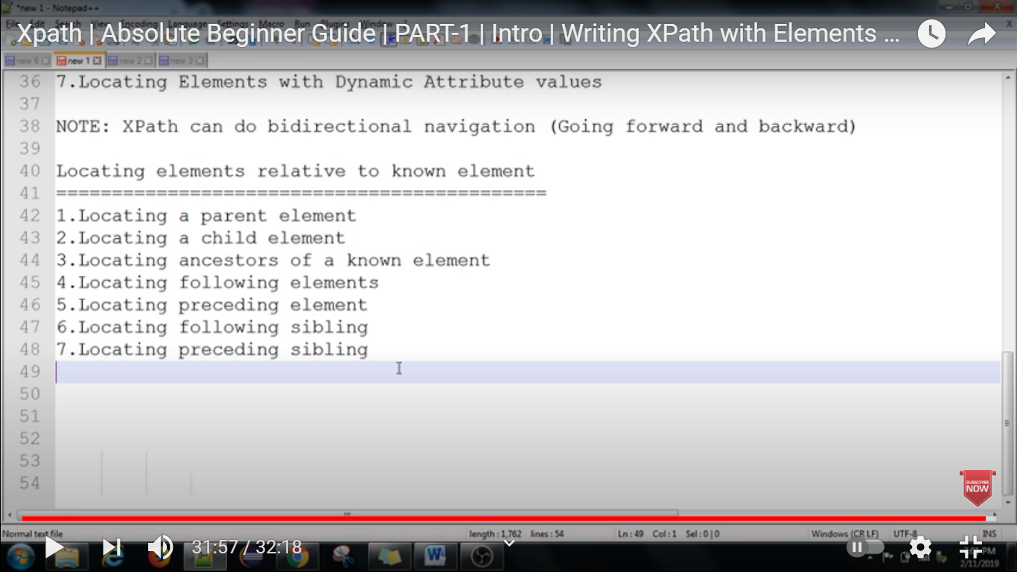

1.Locating a parent element

2.Locating a child element

3.Locating ancestors of a known element

4.Locating the following elements

5.Locating preceding element

6.Locating the following sibling

7.Locating preceding sibling

